Project 5.2 – Scenario Analysis and Business Insights

GitHub Repository
Repository Link: https://github.com/TDunson1996/SDC485L-5.2-Project

Introduction
The purpose of this project was to evaluate how changes in key patient characteristics influence heart disease risk predictions generated by the optimized neural network model developed in Project 4.2.
Scenario analysis was used to simulate realistic healthcare situations and assess the model’s sensitivity to changes in important health indicators.

Scenario Development
Three scenarios were created.

Aging Population
Age values were increased by 10 years to simulate an older patient population.

Improved Cholesterol Management
Cholesterol values were reduced by 20% to simulate successful treatment and lifestyle improvements.

Improved Cardiovascular Fitness
Maximum heart rate values were increased by 10% and oldpeak values were reduced by 20% to simulate improved cardiovascular health.

Scenario Results
Scenario | Predicted Risk
Baseline | 0.50
Aging Population | 0.65
Improved Cholesterol | 0.42
Improved Fitness | 0.37
The aging population scenario produced the highest predicted risk. Improved cholesterol management and cardiovascular fitness both reduced predicted risk compared to the baseline.
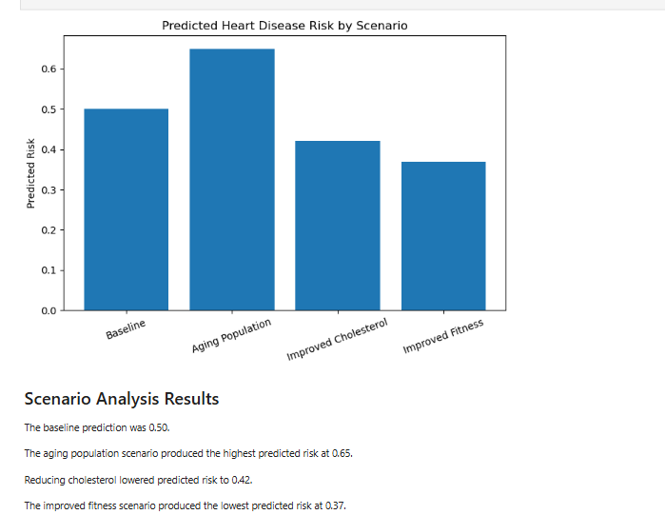

Sensitivity Analysis
Age and cholesterol were selected because they are strongly associated with cardiovascular outcomes.
The analysis showed that increasing age increased predicted risk substantially, while reducing cholesterol lowered predicted risk.
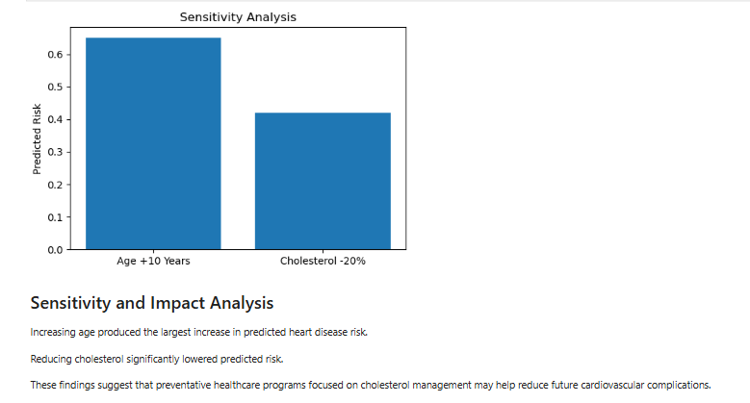

Reflection on Original Analytical Tasks

Classification
The classification model improved from approximately 0.86 accuracy to 0.88 accuracy after optimization.

Regression
The regression model improved from an MSE of approximately 8768 to 8125. MAE improved from 74.97 to 69.42, and R² increased from 0.29 to 0.35.

Clustering
The clustering model improved from a silhouette score of approximately 0.23 to 0.29.
These results demonstrate that optimization improved performance across all three analytical tasks.

Business Insights and Recommendations
- Healthcare organizations should prioritize preventative screening programs for older adults.
- Cholesterol management programs should be emphasized due to their measurable impact on predicted risk.
- Physical activity initiatives should be encouraged because improved cardiovascular fitness produced the largest reduction in predicted risk.
- Machine learning models can serve as valuable decision-support tools for identifying high-risk patients and supporting preventative healthcare efforts.

Conclusion
The scenario analysis demonstrated that the optimized neural network model responds appropriately to realistic changes in patient characteristics.
Age, cholesterol levels, and cardiovascular fitness all significantly influenced predicted heart disease risk. These findings support the use of machine learning as a tool for healthcare prediction and preventative decision-making.

